(Article Title, about 15 words, describing the research conducted, Times New Roman 12, space 1)
Name of First Author, Second Author, Third Author, and so on....
^{1,2,3}Affiliation/University, Country (Times New Roman 11, space 1, spacing after 6 pt)

e-mail (Times New Roman 11, spasi 1, spacing after 6 pt)

example

Zainul Anwar^{1*}, Arif Prasetyo², Syaifuddin³, Syariful Anam⁴
¹Universitas Islam Negeri Sunan Kalijaga Yogyakarta, Indonesia ^{2,4}Universitas Islam Negeri Raden Intan Lampung, Indonesia ³Melbourne University, Australia
Email: anwarzein205@gmail.com, arifpras@gmail.com , etc

Abstrak (Times New Roman 12, Bold, spasi 1)
The abstract briefly describes the research problem and objectives, methods used, and results. The emphasis of abstract writing is mainly on research results. The typing of the abstract is single-spaced with narrower margins than the right and left margins of the main text. Keywords must be included to describe the problem domain studied and the main terms underlying the research implementation. Keywords can be single words or a combination of words. The number of keywords is 3-5 words. These keywords are required for computerization. Searching for the research title and abstract is facilitated by these keywords. The length of the abstract is about 250 words.

Keywords: word 1, word 2, word 3.

INTRODUCTION (TIMES NEW ROMAN 12, SPACE 1)
The total number of words in one article is 4500-6000 words. The introduction mainly contains: (1) the research problem; (2) insights and plans for solving the problem; (3) a summary of theoretical studies related to the problem under study; and (4) the formulation of research objectives. This section may also include expectations of the results and benefits of the research. The length of the introduction section is about 1-2 pages or 5-7 paragraphs and is typed with one space. In this section, the author should present the facts of the literature to explain the similarities and differences between this research and previous studies or explain the novelty of the research being written.

METHOD
Basically, this section explains how the research was conducted. The main materials of this section are (1) research design; (2) population and sample (research targets); (3) data collection techniques and instrument development; (4) and data analysis techniques. For research that uses tools and materials, it is necessary to write down the specifications of the tools and materials. Tool specifications describe the sophistication of the tools used while material specifications describe the type of materials used.

RESULT AND DISCUSSION
The research results presented in this section are "clean" results in the form of field facts relevant to the research focus. Data analysis processes such as statistical calculations and hypothesis testing processes do not need to be presented. Only the results of the analysis and the results of hypothesis testing need to be reported. Tables and graphs can clarify the verbal presentation of research results. Tables and graphs should be commented on or discussed. For qualitative research, the results section contains detailed sections in the form of sub-topics directly related to the research focus and categories.
The discussion in the article aims to: (1) answer the formulation of the problem and research questions; (2) show how the findings were obtained; (3) interpret the findings; (4) link the research findings with established knowledge structures; and (5) generate new theories or modify existing theories.
The research results must be explicitly concluded in answering the problem formulation and research questions. The interpretation of the findings is done using logic and existing theories. Findings in the form of realities in the field are integrated/related to previous research results or to existing theories such as relevant reputable national or international articles. In generating new theories, old theories can be confirmed or rejected, some may need to modify the theory from the old theory.
In an article, it is sometimes unavoidable to organize the writing of research results into "subheadings.” The following is a way of writing such an organizational format, which shows how to write specific things that cannot be separated from an article.

Images and Tables
Place the table label above the table and the figure label at the bottom of the figure. Specify a specific table or figure, such as Table 1 or Figure 1, when referring to a table or figure. An example of writing a table and figure caption is as follows:

Table 1 (Table Title)
No. | Students name | Rate
1 | Ayu Nur Shawmi | 80
2 | Amir Hamzah | 85

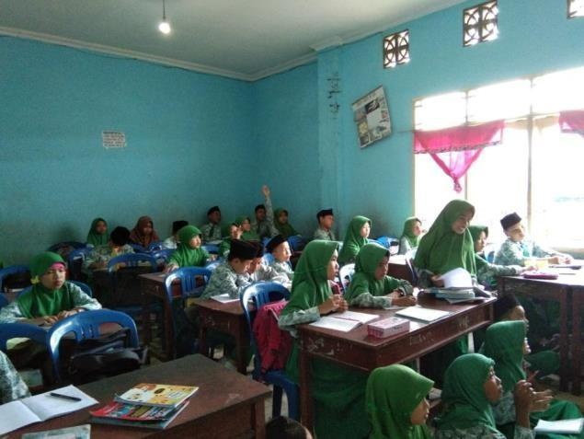
Figure 1: Learners learning
CONCLUSION
The conclusion summarizes the important findings of the research, the contribution of science/theory development to a discipline/new ideas that are the essence of the research findings, and the limitations of this research as recommendations for future research.

REFERENCES
The use of references is at least 80% of articles from reputable national / international journals. The references used are the latest references or the latest 10 years. The writing of the bibliography must refer to the American Psychological Association (APA) Referencing Style 6th Edition and is done sequentially alphabetically downward according to the alphabetical last name of the author (first author if there is more than one author) and without sequential numbers. Use reference management or apps such as Mendeley and Zotero.

Example
Airey, D. (2010). Logo design love: A guide to creating iconic brand identities. Berkeley, CA: New Riders.
Keshavarz, S. M., Shahrokhi, M., & Nejad, M. R. T. (2014). The effect of cooperative learning techniques on promoting writing skills of Iranian EFL learners. International Journal of Language Learning and Applied Linguistics World, 5(1), 78-90.
Megawati. (2012). The correlation between the frequency of writing strategies used and students’ writing achievement of the sixth semester students of English education study program at Sriwijaya University (Undergraduate’s Thesis). Sriwijaya University, Indralaya, Indonesia.
Rogers, C. (2011, November 26). Smartphone could replace wallets. The Dominion Post. Retrieved from http://www.stuff.co.nz/technology /gadgets/6038621/Smartphone-could-replace-wallets [diakses 11-07-2014]

